Dear [customer name],

In these unprecedented times, we understand many are adapting under the mobility circumstances in order to maintain IT infrastructure continuity, especially at sites that are now almost entirely unmanned.

To that end, I wanted to share this tool with you from Schneider Electric: EcoStruxure IT Expert. IT Expert is a cloud-based, remote monitoring tool that gives you visibility to your distributed IT infrastructure and data centers from anywhere, at any time.

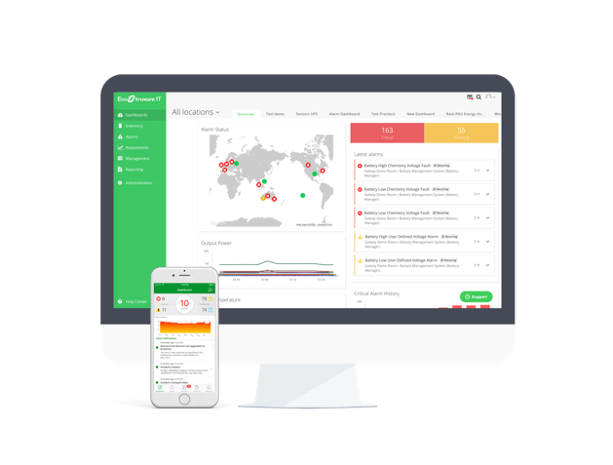 | By using IT Expert, you’ll be able to keep tabs on your critical infrastructures, including IT assets in remote closets and data centers, from anywhere. From your mobile devices, you can zoom in on the operating status of a UPS, PDU, cooling unit, or a server, and assess the health of those assets so that you can anticipate potential infrastructure failure to prevent disruption.

Schneider Electric has decided to extend IT Expert FREE trial from 30 to 90 days*. Connect as many assets as you need to, leverage the support of the Schneider Electric team to quickly deploy the tool, and decide later if it’s something you want to keep or disconnect from. No pressure, no strings.

HERE IS THE LINK TO GET STARTED

*Sign- up before April 30st, 2020.

